FUDMA Journal of Sciences (FJS)
ISSN online: 2616-1370
ISSN print: 2645 - 2944
Vol. 10 No. 9, May, 2026, pp 288 – 294
DOI: https://doi.org/10.33003/fjs-2026-1009-5096
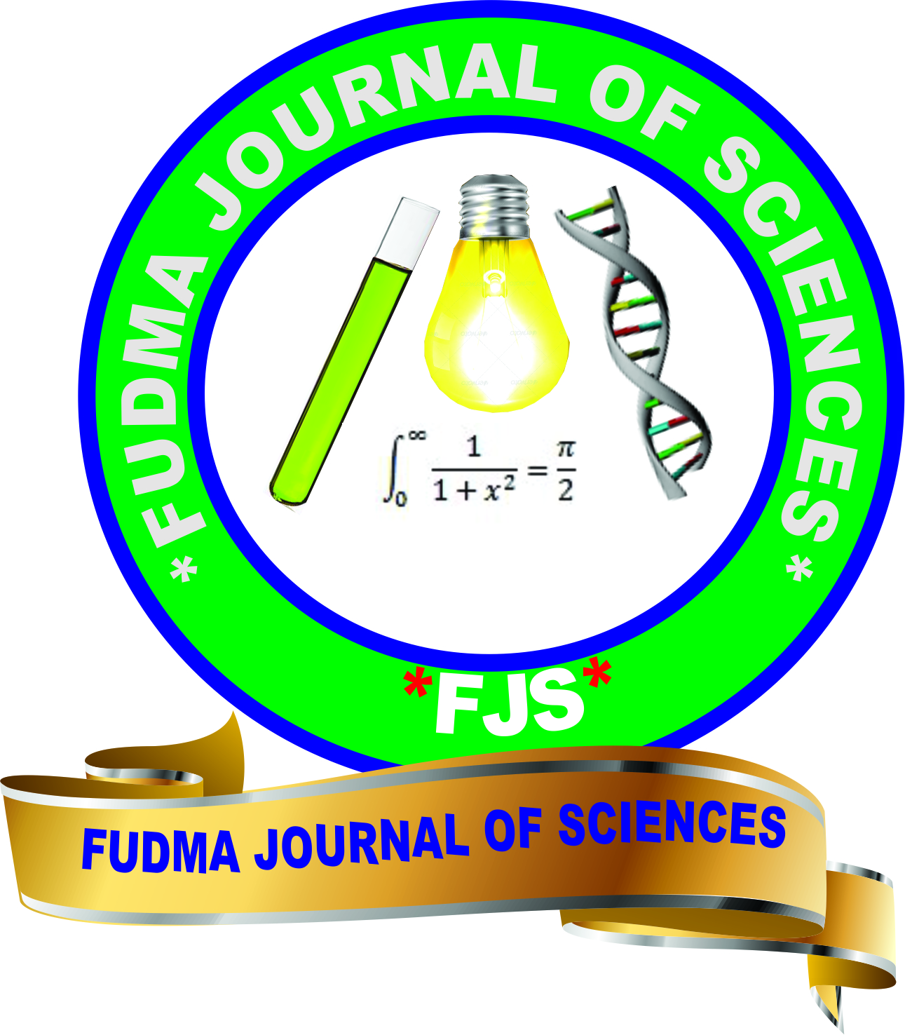


Stomatal Density, Stomatal Index, Stomatal Size and Transpiration Rates in Agave americana and Aloe vera

*Adeniran, S. Sunday, Abdulrahaman, A. Abdullahi, and Sagaya Abdulqudri

Applied Plant Anatomy and Wood Technology Laboratory, Department of Plant Biology, Faculty of Life Sciences, University of Ilorin, Ilorin, Nigeria

*Corresponding authors’ email: adeniran.sa@unilorin.edu.ng Phone: +2347037806777

 |  | ABSTRACT
Received:  Accepted:  Published: | 14 June 2026  25 June 2026  30 June 2026 | The need to reduce water wastage on irrigation of plants in view of the global water crisis necessitates the delimitation of some leaf epidermal features which are relevant to water use efficiency (WUE). Two ornamental plant species namely: Agave americana Linn. and Aloe vera Tourn. & Linn. were studied to determine anatomical and morphological features which are adaptations to water stress and can serve as indices for frequency of watering. The species were propagated in a greenhouse and subjected to 4 watering frequencies each with 5 varying soil moisture contents. After six weeks of watering in the greenhouse, anatomical studies using a light microscope were also carried out. Anatomical adaptations include low stomatal density, low stomatal index and small stomata and low transpiration rate. Leaves with high stomatal density, stomatal index and large stomata also encouraged high rate of transpiration. Analysis of Variance and Duncan’s Multiple Range Test showed that there were significant differences p<0.05 in all the parameters studied. The plant species were listed in increasing order of ability to conserve water and decreasing order of capacity to humidify the atmosphere. The watering frequencies and regimes recommended for the propagation of each species for optimal growth and development without compromising water economy and water use efficiency (WUE). Adhering strictly to these watering frequencies and regimes will ensure efficient use of available water resources and avoidance of water wastage on irrigation.
 | Keywords: | Agave americana, Aloe vera, Stomata, Transpiration rate, Water use efficiency (WUE)

INTRODUCTION
Currently, there is an inadequate supply of fresh water for human use because only a small fraction of the world’s water is accessible freshwater suitable for drinking and daily needs (UN-Water, 2024). Despite this, a lot of water is wasted on irrigation of plants. Thus, the need for judicious use of water for food production (Hokanson, 2006; Fujs & Kashiwase, 2023; UN-Water, 2024; Food and Agriculture Organization, 2025). There are two major ways to increase the water use efficiency (WUE) in agriculture (Wang et al., 2007). One is the engineering-based cropping system where modern irrigation techniques play an important role and much progress has been made to increase water use efficiency by managing irrigation (Fujs, & Kashiwase, 2023; UN-Water, 2024; Food and Agriculture Organization, 2025). The other way is “biological water saving” (bio-water saving) which was coined by Lun Shan in 1991 to emphasize the physiological and ecological bases of water saving by crops in agriculture (Chen et al., 2023). The concept of bio-water saving was further developed by Yuanchun Shi and defined as more agricultural products output with the same or less water input by exploiting the physiological and genetic potential of organisms (Wang, et al., 2007). The core of bio-water saving is to increase ‘water use efficiency’ (WUE) of plants (Alharbi, et al., 2024) and used as an indicator for plant water saving capacity (Hoover et al., 2023).
Stomata play a crucial role in both processes and hold the keys to increase plant WUE, and hence bio-water saving. The physiological and molecular basis of bio-water saving is complicated and is highly linked to drought tolerance mechanisms (Matkowski and Daszkowska-Golec 2023). The efficient water use by plants plays a predominant role in the areas where the water is a limiting factor for production. In addition, water use efficiency (WUE) could be used as a selection criterion, to improve yield in a dry environment (Sadeque et al., 2025; Mutanda et al., 2025). The estimation of the WUE can be based either on evapotranspiration or on plant transpiration; however, the transpiration-based WUE provides a more useful indication of plant performance (Yang, et al., 2025; Lazaridou and Koutroubas, 2004).
Stomatal behaviour or movement has been the focus of intensive research aiming at how stomatal movement is controlled by various environmental factors and how to genetically manipulate plants to increase WUE by enhancing its sensitivity. Much progress has been made in understanding the regulatory network of stomatal movement (Lake and Gray, 2007; Daloso, et al., 2025; Barl, et al., 2025). In contrast, less attention has been paid to the effects of stomatal density and size on photosynthesis and transpiration. At least for one reason, the lack of naturally occurring mutants of varying stomatal density and size in the same genetic background hampered the analysis of the roles of stomatal density in plant water use efficiency. The best compromise between photosynthesis and transpiration would maximize CO₂ uptake and minimize water loss, and ultimately achieve the possible maximal water use efficiency.
Plants with higher transpiration rate have the potential to humidify the atmosphere and thereby have direct relevance to cloud formation and rainfall, while low transpiration rate may result in drought. This translates to mean that plants with higher number of subsidiary cells per stoma will transpire more and thus have the potential of humidifying the atmosphere than plants with lower number of subsidiary cells. This was confirmed in the work of Berg, et al. 2025; Liu et al. 2024 AbdulRahaman and Oladele (2009) and Saadu et al. (2009), It was observed that in some Citrus species, afforestation tree species, species of palms and tuber species, plant species with higher number of subsidiary cells per stoma transpired faster than those with lower number.
In this work, therefore, an attempt was made to elucidate leaf morphological and epidermal features contributing to the failure of A. americana and A. vera to establish or thrive in the field, and on those features that adapt well to water stress, serve as indices for low water requirement and frequency of watering the plants.

MATERIALS AND METHODS
The study materials (Table 1) were propagated by offsets (or pups) of A. americana and A. vera were collected from mature parent plants in their natural habitats. They were identified at the Herbarium Unit of Department of Plant Biology, Faculty of Science, University of Ilorin, Ilorin, Nigeria.

Table 1: List of Ornamental Plant Species Studied
Species | Family | Common names | Origin
Agave americana Linn. | Agavaceae | American century plant, Century plant, Maguey. | Mexico.
Aloe vera Tourn. & Linn. | Liliaceae | Caribbean aloe, Aloe vera, Curacae aloe, Lily of the desert, Plant of immortality, Medicine plant, Elephant gall. | Africa (North, East and South).

Experiments in the Greenhouse
The propagation and raising of offsets of A. americana and A. vera to seedlings was conducted in a greenhouse. Oven-dried soil (at temperature 105°C -110°C) of known measurements (Tables 2 and 3) was distributed in bottom-perforated plastics inside which the seeds, offsets and cuttings were sown. Water was supplied by using a plastic measuring cylinder of 100ml. Depending on the watering regimes; quantity of water supplied was measured and applied based on the watering intervals (Tables 2 and 3). Twenty (20) watering treatments (i.e., watering frequencies and regimes) were used to propagate or raise each species; each watering regime was replicated fifteen times, 2 seeds or offsets or stem cuttings were planted in a plastic i.e. 300 plastics per species were used. In the greenhouse, all factors remain constants except water. All plastics were placed at the same level to expose to all other factors like sunlight except water. The soil and water were weighed and measured out with weighing balance in the following proportions (Gee & Or, 2002; Brady and Weil, 2016).

Table 2: Soil and Water Regimes used for Raising the Study Materials
Soil (g) | Water (g) | % Moisture content (Water regime)
1600 | 400 | 20
1800 | 200 | 10
1900 | 100 | 5
1950 | 50 | 2.5
1975 | 25 | 1.25

The plastics were watered at daily, weekly, biweekly and monthly intervals; each interval consists of the 5 watering regimes or percentage soil moisture contents (Table 3).

Table 3: Watering Frequencies and Regimes used for Raising Seedlings of the Study Materials
Watering intervals | Soil moisture content (%) | Watering intervals | Soil moisture content (%)
Daily | 1.25  2.5  5  10  20 | Biweekly | 1.25  2.5  5  10  20
Weekly | 1.25  2.5  5  10  20 | Monthly | 1.25  2.5  5  10  20

Water Stress Treatments
Water stress was imposed by withholding water from plants (i.e. seeds, offsets, cuttings and seedlings of the study materials) from sowing stage/period for 1 week (7 days), 2 weeks (14 days) and 1 month (30 days) watering intervals, in a sunlit greenhouse. The soil relative water content (SRWC) was divided into four experimental treatments (Table 4) in order to provide differential degrees of water stress preconditioning or to obtain a relatively stable water moisture gradient. Each of these treatments (SRWC) contains five different watering regimes (WR). Having four watering frequencies or intervals – daily, weekly, biweekly and monthly (each containing 1.25cc, 2cc, 5cc, 10cc and 20cc watering regimes). Water stress imposition started from planting of seeds, offsets and cuttings to seedling level in order to detect the effects of the stress at both germination and post germination stages.

Mean Leaf Area
The leaf area was also determined as L x B x 0.75 (Abayomi and Adedoyin, 2004; Koyama & Smith, 2022).
Where: L = Length B = Breadth
Samples of leaves used were taken from different parts of the plant body i.e. upper, middle and lower parts. A sample size of 35 leaves was used for each species (Li, et al., 2023; Kumar & Sharma, 2022).

Determination of Transpiration Rate
A cobalt chloride paper method was used to determine the transpiration rate of each specimen (Obiremi and Oladele, 2001; Dutta, 2003). Strips of filter paper of 2cm x 6cm dimension were cut and immersed in 20% cobalt chloride solution. The strips were thoroughly dried in an oven. The property of cobalt paper is that they are deep blue when dried, but in contact with moisture they turn pink. The blue, dried strips were placed in a sealed, airtight polythene bag and weighed (W1) using Mettler balance. It was transferred quickly to the plastic containers and affixed with a string to the marked small branch (of the plant) with leaves. Two dried cobalt papers were placed on the leaf, one on the upper and the other one on the lower surface of a thick healthy leaf, and were covered completely with glass slides (Dutta, 2003). The time (in seconds) taken for the strips to turn pink was noted. Once turned pink, the bag was quickly untied and sealed again, and transferred to the laboratory and weighed (W2). Weight of water transpired was determined as W2 minus W1. The surface area of leaves used was measured (i.e. as described for the mean leaf area above). Transpiration rate was expressed as mol /m⁻²/ sec⁻¹.

Anatomical Study of the Leaf Epidermis
The anatomy of the leaf epidermis in the seedlings of the 2 plant species that were six weeks old from all the watering regimes was studied as follows:

Isolation of Leaf Epidermal Layers
Leaf segment of an area of 1cm square from each specimen was cut and immersed in concentrated solution of nitric acid or trioxonitrate (v) acid for maceration. The upper (adaxial) and lower (abaxial) surfaces were separated with dissecting needle and forceps, and rinsed with clean water.

Determination of Stomatal Density and Index
The stomatal density was determined as the number of stomata per square millimeter (Stace, 1965).
Stomatal index (SI) was determined as follows:
SI = S/E+S X 100
Where: SI = stomatal index S = number of stomatal per square millimeter
E = number of ordinary epidermal cells per square millimeter.

Determination of Stomatal Size
The mean stomatal size of a species was determined by measuring length and breadth of guard cells using an eye-piece micrometer. A sample of 35 stomata was used per seedlings of a watering regime.

Statistical Analysis
All data generated were analyzed using Analysis of Variance (ANOVA) and Duncan’s Multiple Range Test (DMRT). A probability value of 0.05 was used as benchmark for significant difference between parameters.

RESULTS AND DISCUSSION
Stomatal Anatomy
Agave americana
Stomatal anatomy revealed that tetracytic stomatal complex type was present in the entire regime seedlings with 100% frequency on both abaxial and adaxial surfaces (Figures 1A and B). Thus, stomatal index of similarity was 100% in all regimes because of a single stomatal complex type present on both leaf surfaces (Table 4). Stomatal complex type in A. americana showed some adaptations or adjustment to water stress with particular reference to density, index and size. Stomatal density and stomatal index were low, and stomatal size was small in water-stressed plants than in non-water-stressed.
Stomatal density was higher (4.38mm²) in 20cc daily and 10cc biweekly watering regime seedlings on adaxial surface. It was lower (1.55mm²) in 10cc daily on abaxial. Stomatal density was high on the adaxial surface than on the abaxial surface in most plants (Table 4). Stomatal index was higher (6.12%) in 20cc daily watering regime seedlings on adaxial surface and lower (1.38%) in 10cc daily on abaxial leaf surface (Table 4). Size of stomata is varied from regime to regime, larger size (628.48µm) in 20cc biweekly watering regime seedlings on abaxial surface and smaller (91.95µm) in 10cc biweekly watering regime on adaxial.

Table 4: Some Correlations between Stomatal Features and Transpiration Rate in Agave americana Propagated with Different % Moisture Contents
Watering regimes (%) | Leaf surface | Stomatal density (mm⁻²) | Stomatal index (%) | Stomatal size (um) | Transpiration rate (mol/m⁻²/sec⁻¹)
Daily  1.25 | Abaxial  Adaxial | 2.91c  4.13a | 3.54d  5.15ab | 499.50b  360.56c | 2.91x10⁻⁵_{b}  3.01x10⁻⁵_{b}
2.5 | Abaxial  Adaxial | 2.05c  3.85b | 2.85e  5.35a | 557.62a  331.94c | 1.68x10⁻⁵_{b}  1.70x10⁻⁵_{b}
5 | Abaxial  Adaxial | 2.45c  2.50c | 4.47c  3.56d | 475.34b  222.33d | 3.46x10^{-5b}  3.23x10^{-5b}
10 | Abaxial  Adaxial | 1.55d  2.00cd | 1.38f  2.33e | 381.77c  360.93c | 4.93x10⁻⁵_{b}  5.05x10⁻⁵_{b}
20 | Abaxial  Adaxial | 3.13bc  4.38a | 3.92d  6.12ab | 504.32ab  336.16c | 1.05x10⁻⁵_{b}  1.22x10⁻⁵_{b}
Weekly
10 | Abaxial  Adaxial | 1.57d  1.73d | 2.34e  2.21e | 338.30c  275.50d | 4.21x10⁻⁵_{b}  4.44x10⁻⁵_{b}
20 | Abaxial  Adaxial | 2.75c  2.11cd | 5.39b  4.94c | 440.59b  309.17c | 7.67x10⁻⁵_{b}  1.14x10⁻⁴_{a}
Biweekly  10 | Abaxial  Adaxial | 3.71b  4.38ab | 4.07cd  5.26b | 252.86d  91.95e | 3.50x10⁻⁵_{b}  3.65x10^{-5b}
20 | Abaxial  Adaxial | 2.63c  3.88b | 3.73d  5.11bc | 628.84a  521.25a | 3.55x10⁻⁵_{b}  2.30x10^{-5b}
Monthly  10 | Abaxial  Adaxial | 2.67c  2.00cd | 4.10c  3.01de | 99.56e  93.75e | 6.61x10⁻⁵_{b}  6.44x10⁻⁵_{b}
20 | Abaxial  Adaxial | 2.00cd  3.86b | 2.58e  4.80c | 446.28b  341.19c | 2.42x10⁻⁵b  2.59x10⁻⁵_{b}
Means with the same letters along the columns are not significantly different at p<0.05

Aloe vera
With regard to number of stomata on the leaf surfaces, the leaves of A. vera could be described as hypoamphistomatic (i.e. having more stomata on the lower surface than on the upper surface) or epiamphistomatic (i.e. having more stomata on upper surface than on the lower surface) as observed in some seedlings propagated with different watering regimes. Tetracytic stomatal complex type (Figures 1C and D) occurred on both abaxial and adaxial leaf surfaces of seedlings of all the survived seven watering regimes (Table 5). This stomatal complex type showed some adaptations or adjustments with particular reference to density, index and size. Reduction in stomatal density, index and size was pronounced in water-stressed plants of biweekly watering regimes.
The stomatal index of similarity was 100.00% in all seedlings since there are same stomatal type on both leaf surfaces. Stomatal density, stomatal index and stomatal size varied from one watering regime to another. High stomatal density of 2.63mm² occurred on abaxial surface of 10cc weekly watering regime plants and low stomatal density of 0.38mm² occurred on abaxial and adaxial surfaces of 1.25cc daily and 10cc biweekly watering regime plants. Stomata occupied more area on abaxial leaf surface of 10cc weekly watering regime plants with 4.46% index and low index of 0.91% on the abaxial surface of seedlings propagated with 1.25cc daily watering regime plants. Stomatal area or size also varied with large stomata (534.39µm) on the abaxial leaf surface of 10cc weekly watering regime plants and it was small (144.87µm) on abaxial surface of 10cc biweekly watering regime plants (Table 5).

Table 5: Some Correlations between Stomatal Features and Transpiration Rate in Aloe vera Propagated with % Different Moisture Contents
Watering regimes (%) | Leaf surface | Stomatal density (mm⁻²) | Stomatal index (%) | Stomatal size (µm) | Transpiration rate (mol/m⁻²/sec⁻¹)
Daily  1.25 | Abaxial  Adaxial | 0.38c  0.50c | 0.91d  1.54c | 195.64d  253.12c | 8.66x10⁻⁵_{b}  1.13x10⁻⁴_{a}
2.5 | Abaxial  Adaxial | 0.60c  1.00bc | 1.55c  2.66bc | 236.90c  287.83c | 8.64x10⁻⁵_{b}  1.48x10⁻⁴_{a}
5 | Abaxial  Adaxial | 2.50a  0.75c | 3.65ab  1.86c | 261.67c  249.75c | 2.22x10⁻⁴_{a}  1.49x10⁻⁴_{a}
Weekly  10 | Abaxial  Adaxial | 2.63a  2.13a | 4.46a  3.36ab | 534.39a  334.95b | 1.11x10⁻⁴_{a}  1.47x10⁻⁴_{a}
20 | Abaxial  Adaxial | 0.80c  0.70c | 1.82c  1.51c | 215.00c  284.66c | 6.17x10⁻⁵_{b}  8.67x10⁻⁵_{b}
Biweekly  10 | Abaxial  Adaxial | 0.63c  0.38c | 1.36c  1.04cd | 144.87d  195.58d | 1.93x10⁻⁴_{a}  2.74x10⁻⁴_{a}
20 | Abaxial  Adaxial | 0.80c  0.70c | 1.82c  1.51c | 215.00c  284.66c | 3.39x10⁻⁴_{a}  4.70x10⁻⁴_{a}
Means with the same letters along the columns are not significantly different at p<0.05

Transpiration Rate
Agave americana
There was no clear difference in transpiration rate between water-stressed and non-water-stressed plants. On abaxial leaf surface, higher transpiration rate (7.67x10⁻⁵ mol/m⁻²/sec⁻¹) was recorded in 20cc weekly watering regime seedlings and lower rate (1.05x10⁻⁵ mol/m⁻²/sec⁻¹) in 20cc daily watering plants on abaxial surface. On adaxial surface, rate of transpiration was higher (1.14x10⁻⁴ mol/m⁻²/sec⁻¹) in 20cc daily watering regime while it was lower (1.22x10x10⁻⁵ mol/m⁻²/sec⁻¹) in 20cc daily watering regime. Transpiration rate was higher on the adaxial surface than on the abaxial in most seedlings except in 5cc daily, 20cc weekly, 20cc biweekly and 10cc monthly watering regime seedlings (Table 4). This could be due to high stomatal density on the adaxial surfaces of those plants than on the abaxial surfaces. There was no significant difference at p<0.05 in rate of transpiration on both leaf surfaces in seedlings of A. americana of all watering regimes.

Aloe vera
Water-stressed plants of 10cc weekly and biweekly watering regimes had lower rate of transpiration than non-water-stressed plants. On abaxial leaf surface, high rate of transpiration (3.39x10⁻⁴mol./m⁻²/sec⁻¹) occurred in 20cc biweekly watering regime plants and low (6.17x10⁻⁵ mol./m⁻²/sec⁻¹) in 20cc weekly watering regime plants. Meanwhile, transpiration rate was relatively higher on adaxial surface than on the abaxial surface of majority of the regimes (Table 5), this could be due to vertical orientation of the leaf of this species, unlike in other species where abaxial and adaxial surfaces are physically, and texturally differed. There were some significant differences at p<0.05 in rate of transpiration on both leaf surfaces in seedlings of A. vera of all watering regimes.

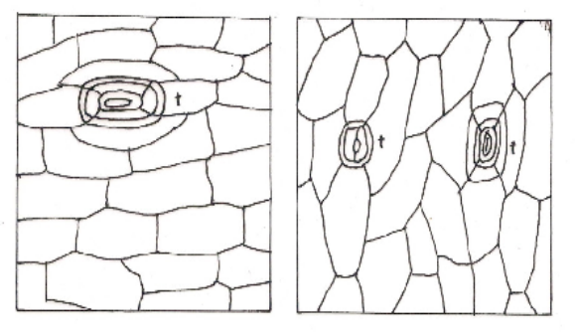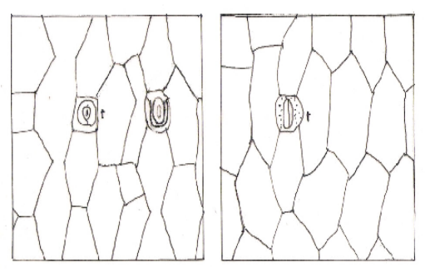
D
C
B
A
Figure 1: Surface View of Leaf Epidermis, Abaxial (A) and Adaxial (B) of Agave americana Propagated with 1.25cc, abaxial (C) and adaxial (D) of Aloe vera Propagated with 5cc Daily of Daily Watering Regime showing tetracytic (t) Stomata x1200

Discussion
The present study demonstrates the vital role of stomatal traits in regulating transpiration and plant water-use efficiency (WUE) in Agave americana and Aloe vera seedlings. Transpiration occurred on both adaxial and abaxial leaf surfaces in both species, consistent with the observation that stomata are present on both surfaces. Based on stomatal distribution, the leaves of the two species can be described as amphistomatic and hypoamphistomatic, meaning that stomata were present on both surfaces, but were generally more abundant on the abaxial surface. This pattern influences the relative rates of water loss from each surface.
Bio-water saving, which refers to increasing WUE per unit of water input, is fundamentally determined by the balance between photosynthesis and transpiration, processes both controlled by stomata (Jansen et al., 2025; Lawson & Vialet-Chabrand, 2019; Ren et al., 2007; Wang et al., 2007; Zhang & Zhang, 2007). The rate of transpiration is influenced by stomatal aperture and the evaporative demand of the surrounding atmosphere (The Columbia Encyclopedia, 2004), confirming that stomata act as pivotal gates for CO₂ and water vapor exchange (Xu & Zhou, 2008). These observations align with previous findings by Hasanuzzaman, et al., (2023); Al-Salman, & Cano, (2023) and Xu, et al., (2023), who reported that higher stomatal density and index are associated with higher transpiration rates, whereas lower values correspond to reduced transpiration, emphasizing that stomatal traits are key determinants of water flux in leaves.
In A. americana, higher stomatal density (4.13 mm⁻²) and stomatal index (5.15%) on adaxial surfaces generally corresponded with higher transpiration rates (3.01 × 10⁻⁵ mol m⁻² s⁻¹) compared to abaxial surfaces, where lower density and index corresponded to lower rates (2.91 × 10⁻⁵ mol m⁻² s⁻¹). These results indicate that stomatal density and index are major contributors to water loss. However, under certain watering regimes, stomatal size became a dominant factor in controlling transpiration, suggesting that larger stomata can facilitate higher water flux even when density is lower (Xu, et al., 2023). Thus, A. americana adapts its stomatal traits to optimize gas exchange while conserving water under varying environmental conditions.
Similarly, in A. vera, adaxial surfaces generally exhibited higher transpiration than abaxial surfaces, except under the 5cc daily watering regime, where abaxial transpiration was higher (2.22 × 10⁻⁴ mol m⁻² s⁻¹) compared to adaxial (1.49 × 10⁻⁴ mol m⁻² s⁻¹). In this species, stomatal size had a greater influence on transpiration than stomatal density or index. Larger stomata (284.66 µm) produced higher transpiration (8.67 × 10⁻⁴ mol m⁻² s⁻¹) compared to smaller stomata (215.00 µm, 6.17 × 10⁻⁴ mol m⁻² s⁻¹). These findings reinforce previous studies demonstrating that guard cell dimensions are critical determinants of water loss and WUE in succulent plants (Wang et al., 2007; Xu, et al., 2023).
The observed correlations between stomatal traits and transpiration across various watering intervals further underscore the importance of stomatal features in regulating water economy. Seedlings exposed to higher watering volumes generally exhibited higher stomatal density and index, facilitating greater transpiration and carbon assimilation. Conversely, water-stressed seedlings showed reduced stomatal density, lower stomatal index, and smaller stomata, reflecting an adaptive water-conservation mechanism (Esau, 1965; Obiremi & Oladele, 2001; Oladele, 2002; AbdulRahaman & Oladele, 2003, 2008, 2009; Saadu et al., 2009).
Additionally, the differences observed between adaxial and abaxial surfaces highlight the influence of leaf surface orientation and anatomical context in regulating transpiration and WUE. In A. americana, higher adaxial stomatal density drove increased water flux, whereas in A. vera, stomatal size was the primary determinant of transpiration rate. These species-specific patterns indicate adaptive strategies for coping with variable water availability and suggest that optimizing stomatal traits could improve bio-water saving and drought resilience.
Overall, the study reinforces that stomatal density, stomatal index, and stomatal size, along with their distribution across leaf surfaces, are central determinants of transpiration and water-use efficiency. Integrating these morphological traits with physiological understanding can guide practical approaches to bio-water saving, irrigation management, and breeding programs aimed at enhancing WUE in succulents and other arid-adapted species.

REFERENCES
Abayomi, Y. A. and Adedoyin, G. A. (2004). Effects of planting date and nitrogen application on growth and yield of contrasting maize (Zea mays L.) genotypes II: morphological characters and their contributions to gain yield. Nigerian of Pure and Applied Science, 19: 1641-1652.

AbdulRahaman, A. A. and Oladele, F. A. (2003). Stomatal complex types, size, density and index in some vegetable species in Nigeria. Nigerian Journal of Botany, 16: 144-150.

AbdulRahaman, A. A. and Oladele, F. A. (2008). Global warming and stomatal complex types. Ethnobotanical Leaflets, 12: 553 – 56.

AbdulRahaman, A. A. and Oladele, F. A. (2009). Stomatal features and humidification potentials of Borassus aethiopum, Oreodoxa regia and Cocos nucifera. African Journal of Plant Science, 3(2): 059-063.

Alharbi, S., Felemban, A., Abdelrahim, A., & Al-Dakhil, M. (2024). Agricultural and technology-based strategies to improve water-use efficiency in arid and semiarid areas. Water, 16(13), 1842. https://doi.org/10.3390/w16131842

Al-Salman, Y., Ghannoum, O., & Cano, F. J. (2023). Midday water use efficiency in sorghum is linked to faster stomatal closure rate, lower stomatal aperture and higher stomatal density. The Plant Journal, 115(6), 1661–1676. https://doi.org/10.1111/tpj.16346

Barl, L., Benato, B. D., Genze, N., Grimm, D. G., Gigl, M., Dawid, C., & Avramova, V. (2025). The combined effect of decreased stomatal density and aperture increases water use efficiency in maize. Scientific Reports, 15, 13804. https://doi.org/10.1038/s41598-025-94833-1

Berg, L.S., Betekhtin, A., Milewska-Hendel, A. & Raissig, M. T. (2025). Stomatal anatomy and gas exchange dynamics in the Brachypodium distachyon complex. BMC Plant Biol 25, 1360. https://doi.org/10.1186/s12870025-07312-0

Brady, N. C., & Weil, R. R. (2016). The Nature and Properties of Soils (15th ed.). Pearson.

Chen, Y., Leng, Y.-N., Zhu, F.-Y., Li, S.-E., Song, T., & Zhang, J. (2023). Water-saving techniques: Physiological responses and regulatory mechanisms of crops. Advanced Biotechnology, 1(4), 3. https://doi.org/10.1007/s44307-023-00003-7

Daloso, D. M., Cardoso, A. A., & ForCE Metabolomics. (2025). Stomata as an important hub for the ecophysiology of leaves and nonfoliar tissues. Plant Physiology, 200(3), kiaf637. https://doi.org/10.1093/plphys/kiaf637

Dutta, A. C. (2003). Botany for Degree Students, Revised 6th Edition. Oxford University Press, New Delhi. p. 240.

Esau, K. (1965). Plant Anatomy. 2nd Edition. John Wiley and Son Inc., New York. p. 52.

Food and Agriculture Organization of the United Nations. (2025). The State of the World’s Land and Water Resources for Food and Agriculture 2025. FAO. https://www.fao.org/publications/fao-flagship-publications/the-state-of-the worlds-land-and-water-resources-for-food-and-agriculture/en

Fujs, T., & Kashiwase, H. (2023, August 23). Strains on freshwater resources: The impact of food production on water consumption. World Bank Blogs. https://blogs.worldbank.org/en/opendata/strains-freshwater-resources-impact food-production-water-consumption

Gee, G. W., & Or, D. (2002). Particle-size analysis. In J. H. Dane & G. C. Topp (Eds.), Methods of Soil Analysis. Part 4. Physical Methods (SSSA Book Series, Vol. 5, pp. 255–293). Soil Science Society of America.

Hasanuzzaman, M., Zhou, M., & Shabala, S. (2023). How does stomatal density and residual transpiration contribute to osmotic stress tolerance? Plants, 12(3), 494. https://doi.org/10.3390/plants12030494

Hokanson, A. (2006). Unsuitainable Population Growth Projected to Stress California Water Supply. Bay City News, Inc., California.

Hoover, D. L., Abendroth, L. J., Browning, D. M., Saha, A., Snyder, K., Wagle, P., … Scott, R. L. (2023). Indicators of water use efficiency across diverse agroecosystems and spatiotemporal scales. Science of the Total Environment, 864, 160992. https://doi.org/10.1016/j.scitotenv.2022.160992

Jansen, M. A. K., Ač, A., Grace, J., & Urban, O. (2025). A global meta-analysis of water use efficiency proxies reveals that UV radiation decreases transpiration without improving WUE. Plant, Cell & Environment, 48(9), 6734–6747. https://doi.org/10.1111/pce.15643

Koyama, K., & Smith, D. D. (2022). Scaling the leaf length-times-width equation to predict total leaf area of shoots. Annals of Botany, 130(2), 215–230. https://doi.org/10.1093/aob/mcac043

Kumar, P., & Sharma, R. (2022). Sampling strategies for physiological assessment of leaf traits in wheat under drought stress. Journal of Agronomy and Crop Science, 208(5), 641–651. https://doi.org/10.1111/jac.12587

Lake, J. A. and Gray, J. E. (2007). A diversity of scales. New Physiologist, 173: 670 – 673.

Lawson, T., & Vialet-Chabrand, S. (2019). Speedy stomata, photosynthesis and plant water use efficiency. New Phytologist, 221(1), 93–98. https://doi.org/10.1111/nph.15330

Lazaridou, M. and Koutroubas, S. D. (2004). Drought Effect on Water Use Efficiency of Berseem Clover at various Growth Stages. 4th International Crop Science Congress. The Regional Institute Ltd.

Li, X., Zhang, Y., & Wang, J. (2023). Effects of canopy position on leaf gas exchange and photosynthetic traits in maize. Photosynthetica, 61(2), 285–294. https://doi.org/10.32615/ps.2023.016

Liu L, Ashraf, M. A, Morrow, T, & Facette, M. (2024). Stomatal closure in maize is mediated by subsidiary cells and the PAN2 receptor. New Phytol. 241(3):1130 1143. doi: https://doi.org/10.1111/nph.19379. Epub 2023 Nov 7. PMID: 37936339.

Matkowski H and Daszkowska-Golec A (2023) Update on stomata development and action under abiotic stress. Front. Plant Sci. 14:1270180. doi: https://doi.org/10.3389/fpls.2023.1270180

Mutanda, M., Shimelis, H., Chaplot, V., Shamuyarira, K. W., & Figlan, S. (2025). Agronomic performance and water use efficiency of newly developed wheat populations under drought-stressed and non-stressed conditions. Discover Applied Sciences, 7, 176. https://doi.org/10.1007/s42452-025-06605-1

Obiremi, E. O. and Oladele, F. A. (2001). Water-conserving stomatal systems in selected Citrus species. South African Journal of Botany, 67: 258-260.

Oladele, F. A. (2002). The Only One We Have. The 62nd Inaugural Lecture, University of Ilorin, Ilorin.

Ren, H., Wei, K., Jia, Davies, W. J. and Zhang, J. (2007). Modulation of root signals in relation to stomatal sensitivity to root-sourced abscisic acid in drought-affected plants. Journal of Integrative Plant Biology, 49(10): 1410 – 1420.

Saadu, R. O., AbdulRahaman, A. A. and Oladele, F. A. (2009). Stomatal complex types and humidification potential of some root tuber species. African Journal of Plant Science, 3(5): 107 – 112.

Sadeque, A., Ahmed, S., Islam, M. A., Muktadir, M. A., Rahman, M. Z., Islam, M. S., Idris, A. M. (2025). Enhancing water use efficiency in grain legumes: From agronomic practices to breeding strategies. Journal of Plant Nutrition. https://doi.org/10.1080/01904167.2025.2544701

Stace, C. A. (1965). Cuticular studies as an aid to plant taxonomy. Bull. Brit. Mus. (Nat. His.) Bot., 4: 1-78.

The Columbia Encyclopedia (2004). Transpiration. 6th Edition. Columbia University Press, Columbia.

UN-Water. (2024). UN World Water Development Report 2024: Water for prosperity and peace. UNESCO. https://www.unesco.org/en/world-water-report-2024

Wang, Y., Chen, X., & Xiang, C.-B. (2007). Stomatal density and bio-water saving. Journal of Integrative Plant Biology, 49(10), 1435–1444. https://doi.org/10.1111/j.1672-9072.2007.00554.x

Xu, Z. Z. and Zhou, G. S. (2008). Responses of leaf stomatal density to water status and its relationship with photosynthesis in a grass. Journal of Experimental Botany, 59(2): 3317 – 3325.

Xu, Z., Tian, Y., Liu, Z., & Xia, X. (2023). Comprehensive effects of atmosphere and soil drying on stomatal behavior of different plant types. Water, 15(9), Article 1675. https://doi.org/10.3390/w15091675

Yang, S., Zhang, J., Han, J., Bai, Y., Xun, L., Zhang, S., Cao, D., Wang, J. (2025). The ratio of transpiration to evapotranspiration dominates ecosystem water use efficiency response to drought. Agricultural and Forest Meteorology, 363, 110423, https://doi.org/10.1016/j.agrformet.2025.110423

Zhang, Z-B. and Zhang, J. (2007). Water saving agriculture: an urgent issue. Journal of Integrative Plant Biology, 49(10): 1409 – 1409.

©2026 This is an Open Access article distributed under the terms of the Creative Commons Attribution 4.0 International license viewed via https://creativecommons.org/licenses/by/4.0/ which permits unrestricted use, distribution, and reproduction in any medium, provided the original work is cited appropriately.


